- Install Jenkins and run Jenkins on port number 8081.

1. Prerequisites

Ensure the following before starting:

* **Amazon Linux 2023 EC2 instance**
* SSH access with a user that has `sudo` privileges
* **Java 11 or Java 17** (required by Jenkins)
* Internet access from the instance
* **Security Group** allowing inbound traffic on **port 8081**
* `wget` and `curl` utilities (usually preinstalled)

2. Step-by-Step Implementation

### Step 1: Update the System

```bash
sudo dnf update -y
```
### Step 2: Install Java (Recommended: Java 17)

```bash
sudo dnf install java-17-amazon-corretto -y
```
Verify Java:

```bash
java -version
```
### Step 3: Add Jenkins Repository

```bash
sudo wget -O /etc/yum.repos.d/jenkins.repo \
https://pkg.jenkins.io/redhat-stable/jenkins.repo
```

Import Jenkins GPG key:

```bash
sudo rpm --import https://pkg.jenkins.io/redhat-stable/jenkins.io-2023.key
```
### Step 4: Install Jenkins

```bash
sudo dnf install jenkins -y
```
### Step 5: Configure Jenkins to Run on Port 8081

Edit the Jenkins configuration file:

```bash
sudo vi /usr/lib/systemd/system/jenkins.service
```
Find:

```text
JENKINS_PORT="8080"
```
Change to:

```text
JENKINS_PORT="8081"
```
Save and exit.

### Step 6: Start and Enable Jenkins

```bash
sudo systemctl start jenkins
sudo systemctl enable jenkins
```
3. Validation Steps

1. **Check Jenkins service status**

```bash
sudo systemctl status jenkins
```
✔ Status should be **active (running)**

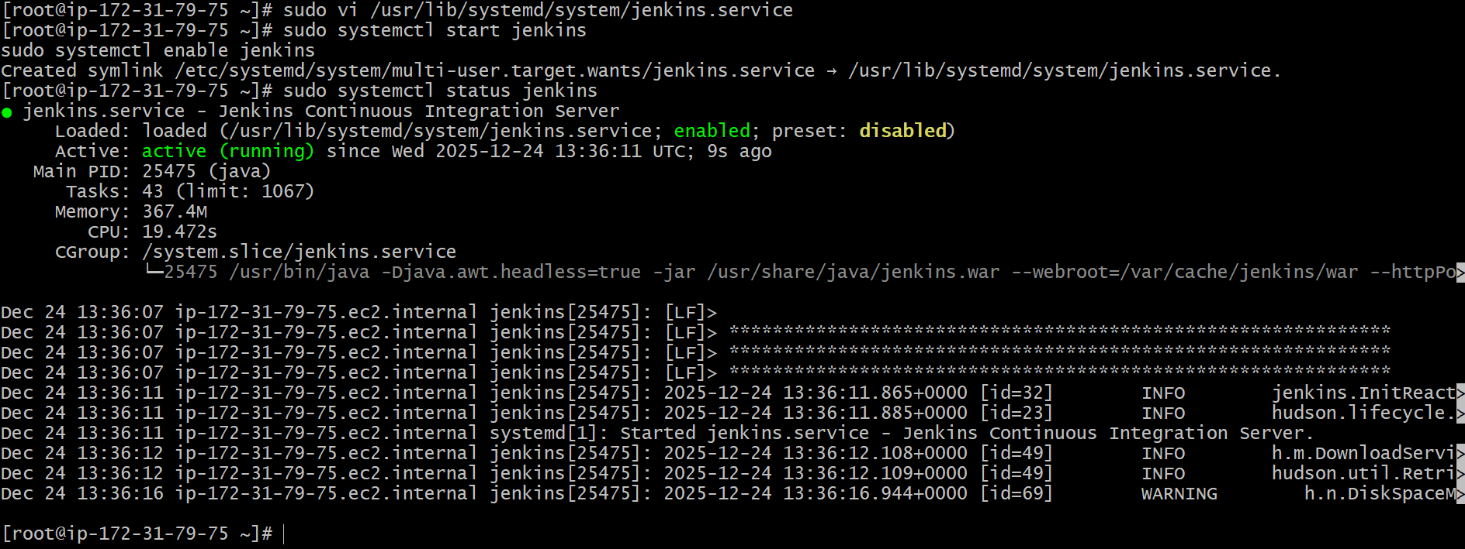

2. **Open Jenkins in a browser**

```text
http://<EC2-Public-IP>:8081
```
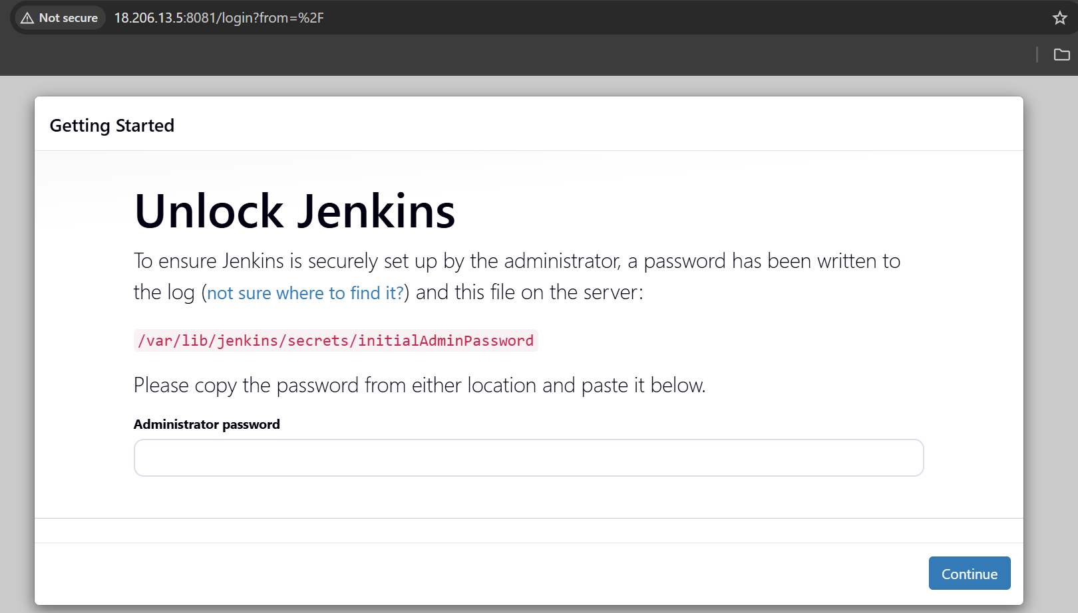

3. **Retrieve initial admin password**

```bash
sudo cat /var/lib/jenkins/secrets/initialAdminPassword
```
4. Paste the password into the Jenkins setup screen and complete the setup wizard.

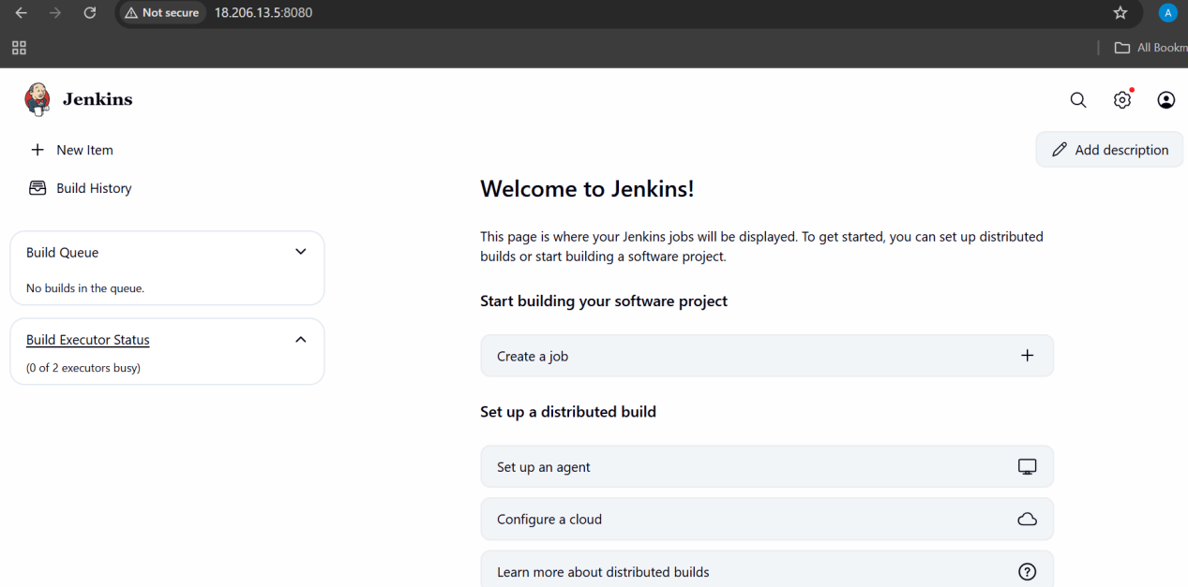

4. Conclusion

Jenkins was successfully installed on **Amazon Linux 2023** and configured to run on **port 8081**.
The service is running correctly and is accessible through the browser for CI/CD configuration.

- Secure Jenkins server

To secure my jenkins server , I will create new password for my admin user of jenkins at my
Admin -- Security -- Password

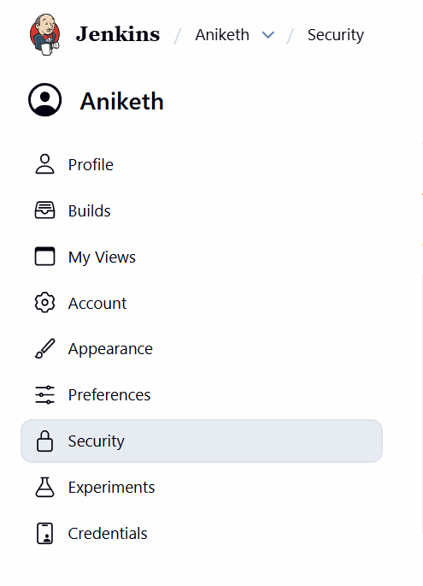

And I will delete the “initialadminpassword” from /var/lib/jenkins/secrets

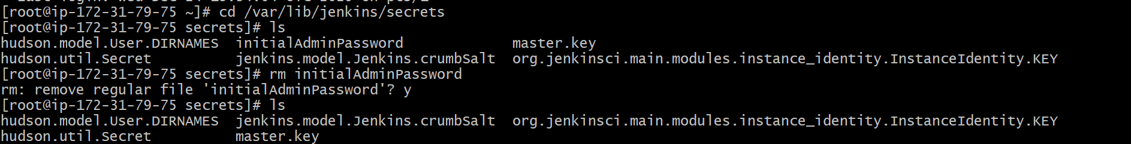

Conclusion
My jenkins server is secure now.

- Create users called DevOps, Testing in Jenkins with Limited access.

1. Prerequisites

Ensure the following are already configured:

* Jenkins security is **enabled**
* Authentication: **Jenkins’ own user database**
* Authorization: **Matrix-based security**
*(or Role-Based Authorization if installed)*
* Logged in as **Admin**

2. Step-by-Step Implementation

Install the plugin “ROLE-BASED-AUTHORIZATION ”

### Step 1: Create Users

1. Go to **Manage Jenkins → Users**
2. Click **Create User**

#### Create User: DevOps

* Username: `DevOps`
* Password: (strong password)
* Full Name: `DevOps User`
* Email: optional
Click **Create User**

#### Create User: Testing

Repeat the same steps:

* Username: `Testing`
* Password: (strong password)
* Full Name: `Testing User`

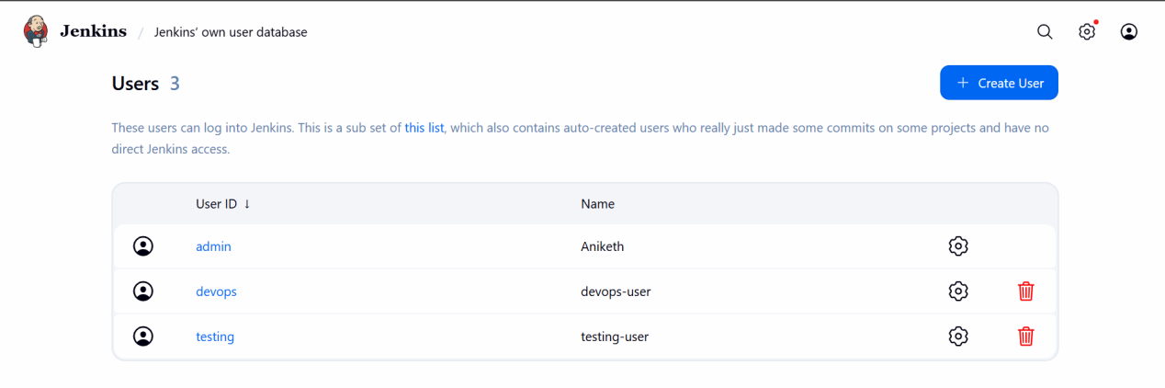

### Step 2: Configure Matrix-Based Security

1. Go to **Manage Jenkins → Security**
2. Under **Authorization**, select **Matrix-based security**
3. Add users:

* `DevOps`
* `Testing`

### Step 3: Assign Permissions (Limited Access)

#### Permissions for **DevOps**

Grant:

* Overall → Read
* Job → Read
* Job → Build
* Job → Configure
* Job → Workspace
* View → Read

❌ Do NOT grant:

* Overall → Administer
* Manage Plugins
* Manage Nodes

#### Permissions for **Testing**

Grant:

* Overall → Read
* Job → Read
* Job → Build
* Job → Workspace
* View → Read

❌ Do NOT grant:

* Job → Configure
* Overall → Administer

### Step 4: Save Configuration

Click **Save**.

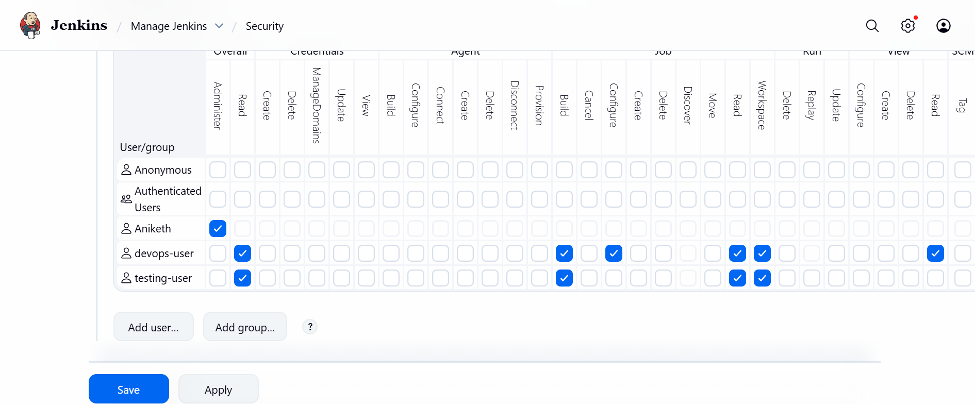

3. Validation Steps

### Test DevOps User

1. Log out from Admin
2. Log in as `DevOps`
3. Verify:

* Can view and configure jobs
* Can trigger builds
* Cannot access **Manage Jenkins**

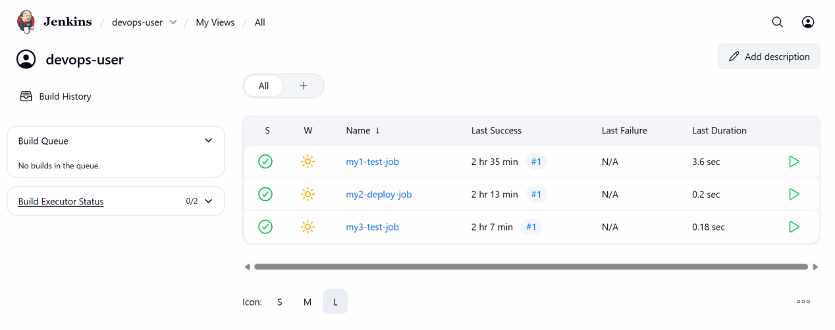

### Test Testing User

1. Log out
2. Log in as `Testing`
3. Verify:

* Can view jobs
* Can trigger builds
* Cannot configure jobs
* Cannot access **Manage Jenkins**

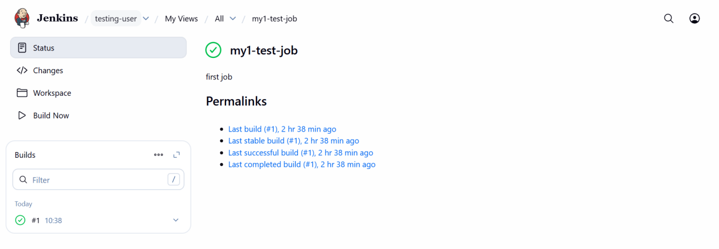

4. Conclusion

Users **DevOps** and **Testing** were successfully created with **role-appropriate limited access**.
This ensures controlled permissions while maintaining security and operational efficiency.

- Configure labels and restrict the jobs to execute based on label only.

1. Prerequisites

Ensure the following are already done:

* Jenkins is installed and running
* At least **one agent/node** exists (can be the Jenkins master or a separate agent)
* Jobs (Build / Test / Deploy) already created
* Admin access to Jenkins

2. Understanding Labels in Jenkins

🔹 **Labels** are tags assigned to nodes
🔹 Jobs can be restricted to run **only on nodes with specific labels**

Example:

* `build-node`
* `test-node`
* `deploy-node`

3. Configure Node Labels

### Step 1: Go to Node Configuration

1. Jenkins Dashboard → **Manage Jenkins**
2. Click **Nodes and Clouds**
3. Click on **Built-In Node** (or your agent node)
4. Click **Configure**

### Step 2: Add Labels

In **Labels** field, add:

```
build test deploy
```

(Separate multiple labels with space)

Click **Save**

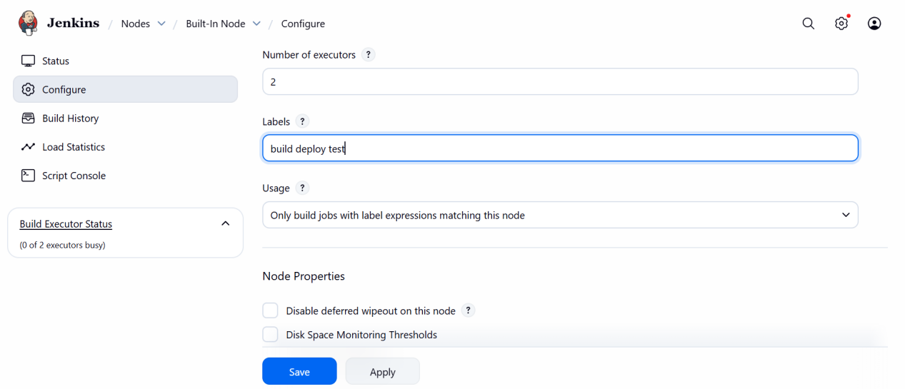

## 4. Restrict Jobs to Run on Specific Labels

---

### Job 1: Build Job (Label: build)

1. Open **Techie-Build-Job**
2. Click **Configure**
3. Check:

```
Restrict where this project can be run
```
4. Label Expression:

```
build
```
5. Save

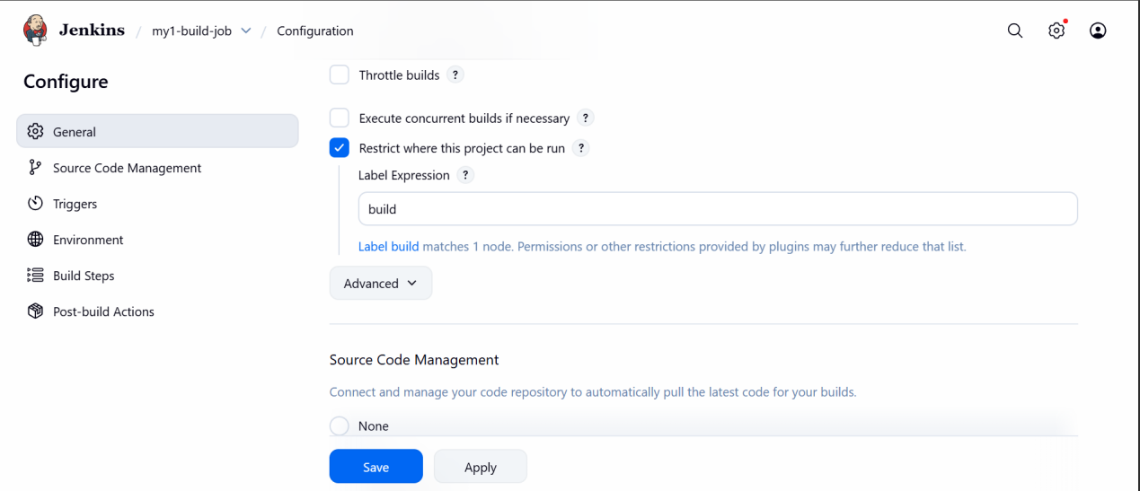

### Job 2: Test Job (Label: test)

1. Open **Techie-Test-Job**
2. Configure
3. Enable **Restrict where this project can be run**
4. Label Expression:

```
test
```
5. Save

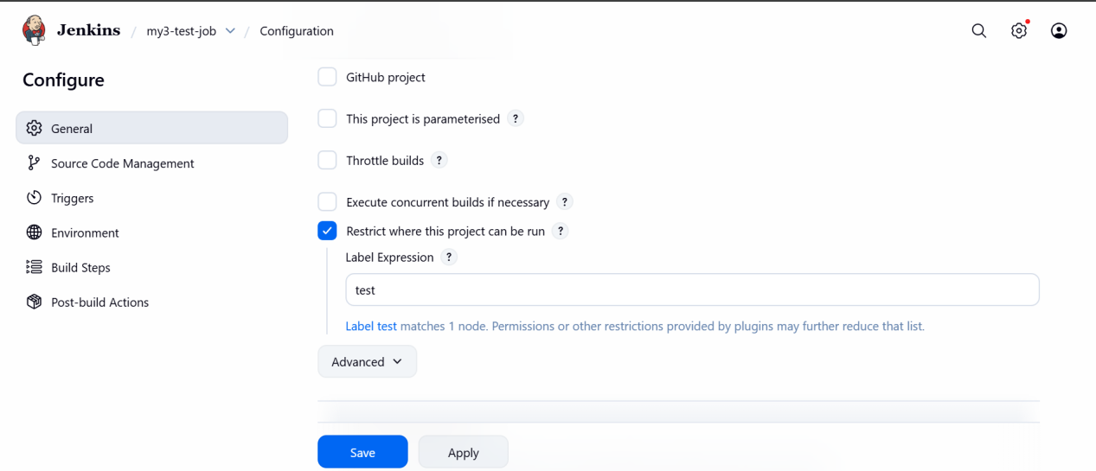

### Job 3: Deploy Job (Label: deploy)

1. Open **Techie-Deploy-Job**
2. Configure
3. Enable **Restrict where this project can be run**
4. Label Expression:

```
deploy
```
5. Save

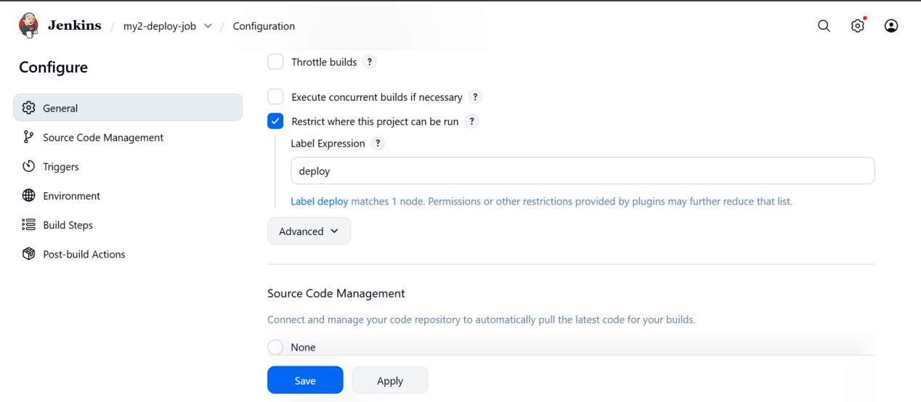

## 5. Validation Steps

### Verify Node Label Assignment

* Go to **Manage Jenkins → Nodes and Clouds**
* Click the node
* Confirm labels exist:

```
build test deploy
```
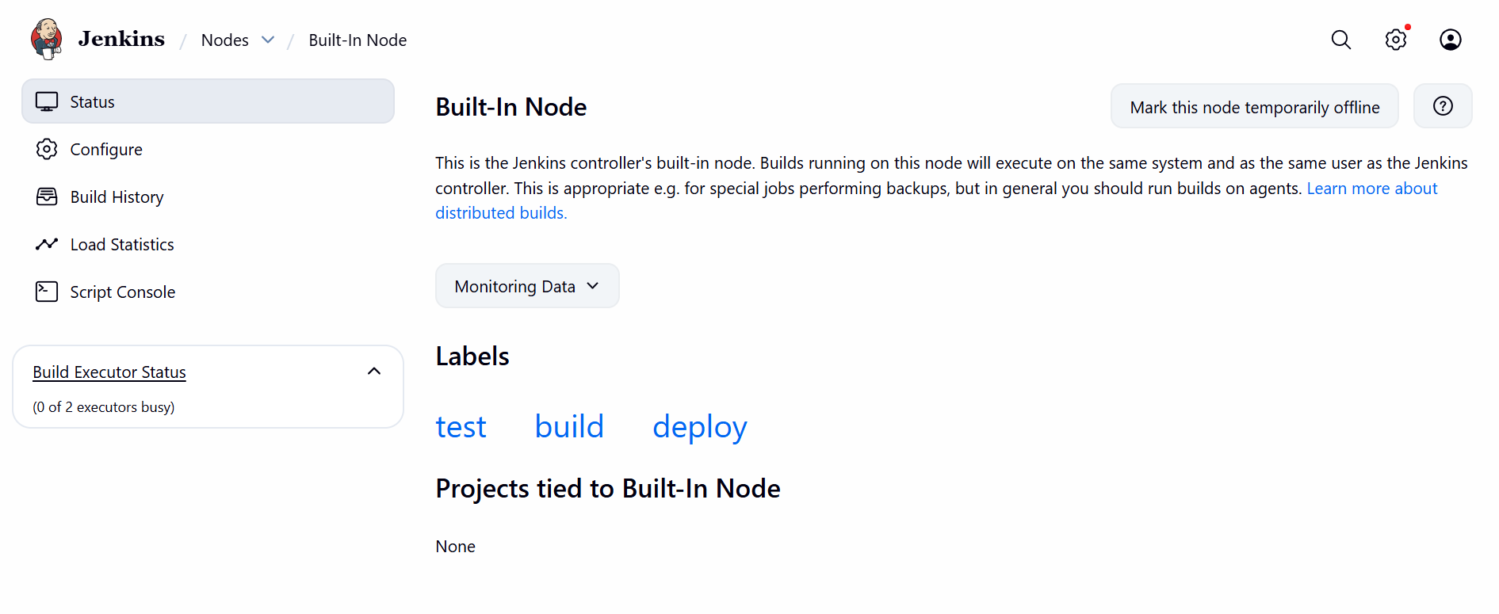

## 7. Conclusion

Node labels were successfully configured, and Jenkins jobs were restricted to run only on their assigned labeled nodes.
This ensures controlled execution, better resource usage, and improved CI/CD reliability.

- Create Three sample jobs using the below URL.
https://github.com/betawins/Techie_horizon_Login_app.git

1. Prerequisites

Ensure the following are already completed:

* Jenkins is running and secured
* Users (Admin / DevOps / Testing) exist
* Git is installed on Jenkins server:

```bash
sudo dnf install git -y
```

* Jenkins has **Git Plugin** installed
(`Manage Jenkins → Plugins → Installed`)

2. GitHub Repository Details

**Repository:**

```
https://github.com/betawins/Techie_horizon_Login_app.git
```

This will be used for all three jobs.
3. Job 1 – Build Job (Compile / Basic Build)

### Step 1: Create Job

1. Go to **Jenkins Dashboard**
2. Click **New Item**
3. Enter job name:

```
Techie-Build-Job
```
4. Select **Freestyle project**
5. Click **OK**

### Step 2: Configure Source Code Management

* Select **Git**
* Repository URL:

```
https://github.com/betawins/Techie_horizon_Login_app.git
```
* Branch:

```
*/main
```

### Step 3: Add Build Step

Click **Add build step → Execute shell**

```bash
echo "Building application..."
ls -l
```

### Step 4: Save & Build

Click **Save → Build Now**

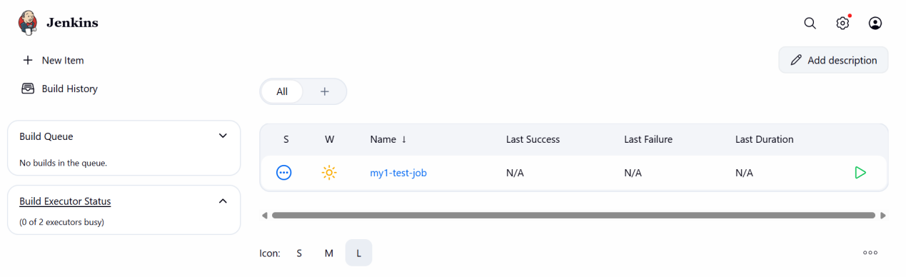

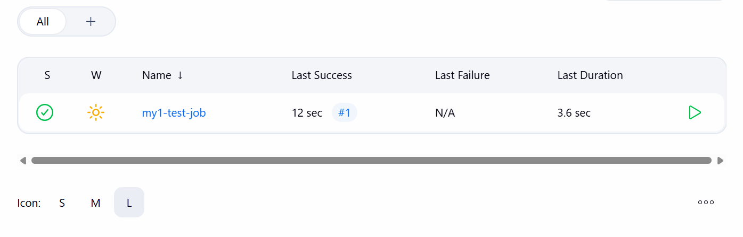

4. Job 2 – Test Job

### Step 1: Create Job

* Click **New Item**
* Name:

```
Techie-Test-Job
```
* Select **Freestyle project**

### Step 2: Configure Git

Same as above:

```
https://github.com/betawins/Techie_horizon_Login_app.git
```

### Step 3: Add Build Step

Add **Execute shell**:

```bash
echo "Running test cases..."
ls -l
```

(Optional: add real test commands if available.)

### Step 4: Save & Build

Click **Save → Build Now**

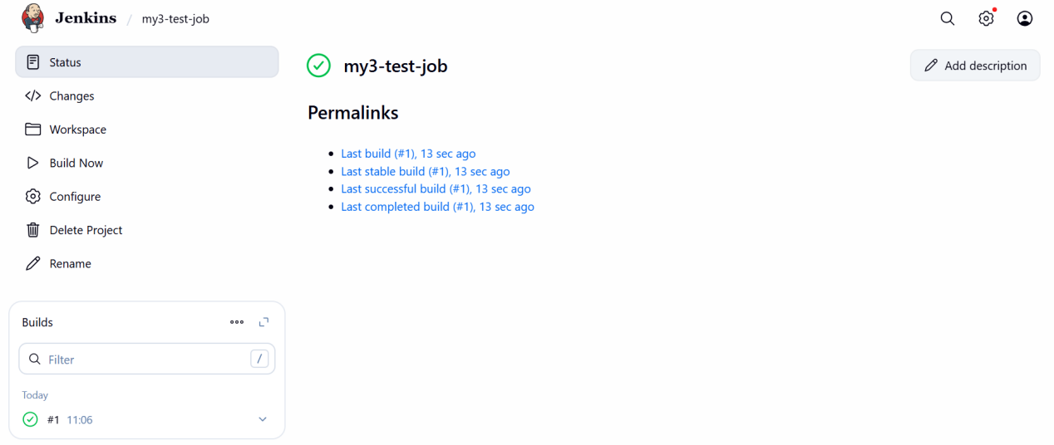

5. Job 3 – Deploy Job

### Step 1: Create Job

* Click **New Item**
* Name:

```
Techie-Deploy-Job
```
* Choose **Freestyle project**

### Step 2: Configure Git

Same Git repo:

```
https://github.com/betawins/Techie_horizon_Login_app.git
```

### Step 3: Add Build Step

Add **Execute shell**:

```bash
echo "Deploying application..."
mkdir -p /tmp/techie_app_deploy
cp -r * /tmp/techie_app_deploy/
```

### Step 4: Save & Build

Click **Save → Build Now**

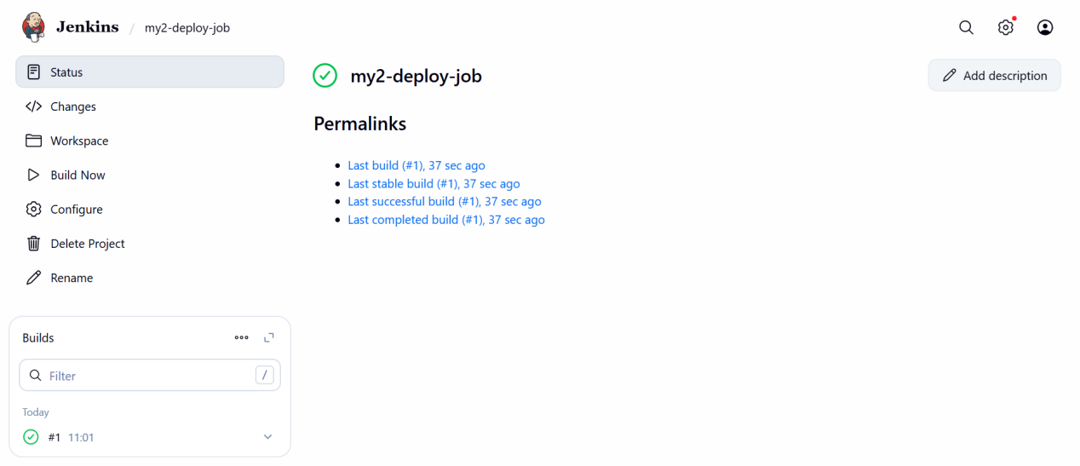

6. Validation Steps

✔ All three jobs run successfully
✔ GitHub repository is cloned in each job
✔ Console output shows build, test, and deploy messages

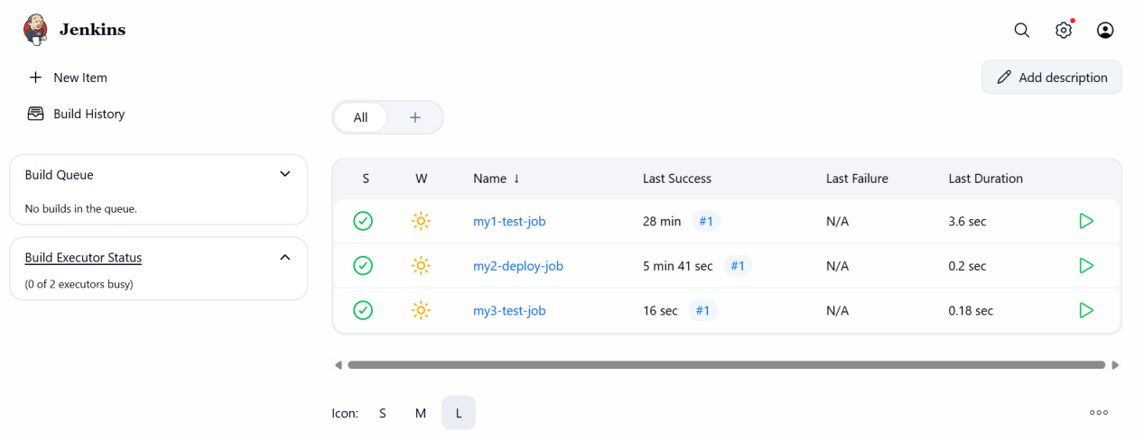

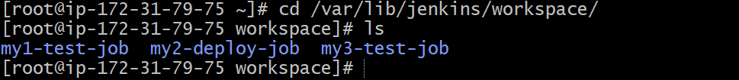
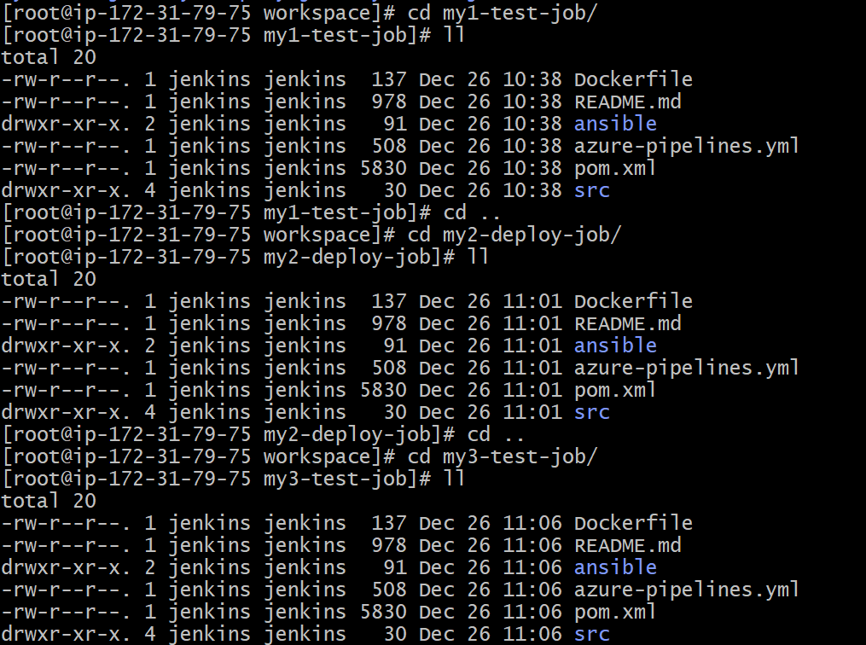

7. Conclusion

Three Jenkins jobs — **Build**, **Test**, and **Deploy** — were successfully created using the provided GitHub repository.
Each job performs its intended function and demonstrates a basic CI/CD workflow.

- Create one Jenkins job using git hub Private repository.

- Prerequisites

Before starting, ensure the following are available:

### Jenkins & System

* Jenkins installed and running
* Admin access to Jenkins
* Git installed on Jenkins server

```bash
git --version
```
### GitHub Requirements

* Access to the private repository:

```
https://github.com/wallmore/linux-handbook.git
```
* GitHub **Personal Access Token (PAT)** with:

* ✅ `repo` permission

- Step-by-Step Implementation

### Step 1: Generate GitHub Personal Access Token (PAT)

1. Login to GitHub
2. Go to:

```
Settings → Developer settings → Personal access tokens → Tokens (classic)
```
3. Click **Generate new token**
4. Select scopes:

* ✅ repo
5. Generate and **copy the token** (save it securely)

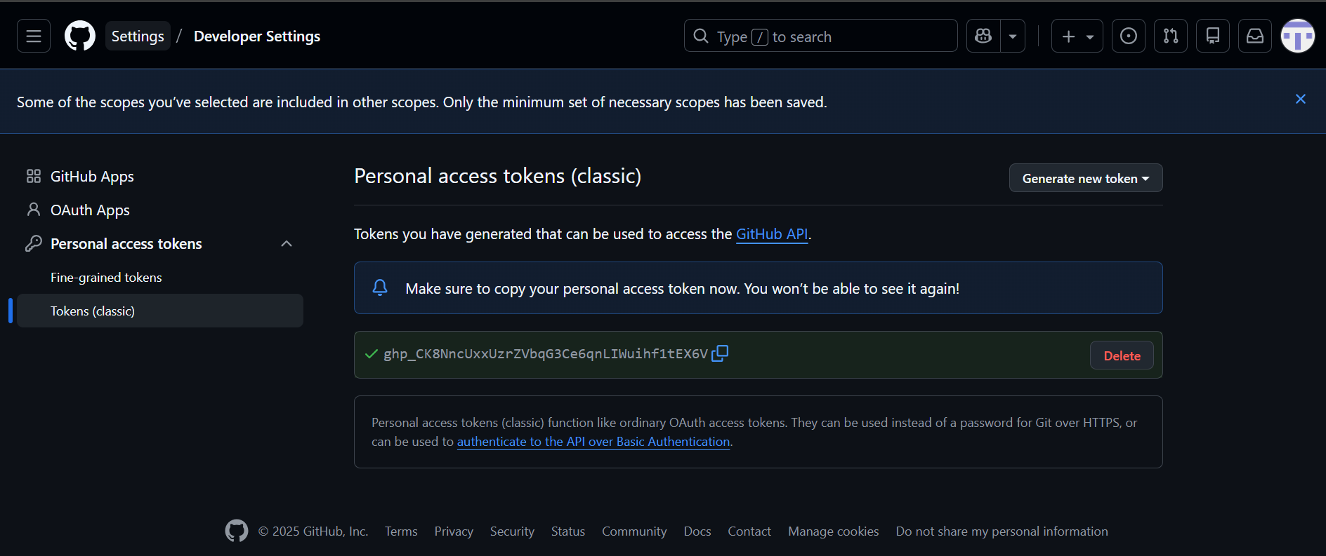

### Step 2: Add GitHub Credentials to Jenkins

1. Go to:
```
Manage Jenkins → Credentials
```
2. Click:
```
(global) → Add Credentials
```
3. Fill in:

* **Kind:** Username with password
* **Username:** Your GitHub username
* **Password:** Paste GitHub PAT
* **ID:** github-linux-handbook
* **Description:** GitHub private repo access

4. Click **Create**

### Step 3: Create Jenkins Job

1. Go to **Jenkins Dashboard**
2. Click **New Item**
3. Job Name:
```
linux-handbook-job
```
4. Select **Freestyle project**
5. Click **OK**

### Step 4: Configure Git Repository

In **Source Code Management**:

✔ Select **Git**

**Repository URL:**
```
https://github.com/wallmore/linux-handbook.git
```
**Credentials:**
```
github-linux-handbook
```
**Branch:**
```
*/main
```
(or `*/master` if applicable)

### Step 5: Add Build Step

Click:

```
Add build step → Execute shell
```

Add:

```bash
echo "Repository cloned successfully"
ls -l
```
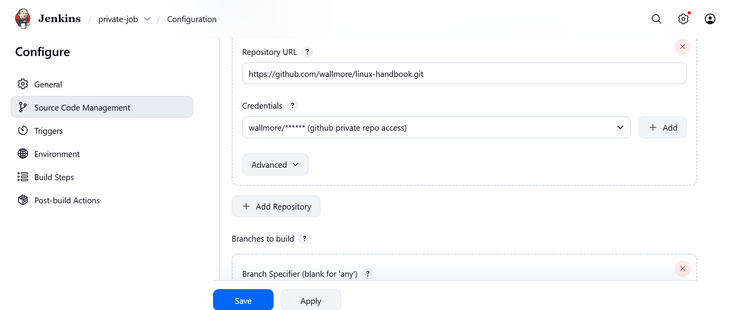

### Step 6: Save and Build

Click **Save** → **Build Now**

3. Validation Steps

✔ Job status turns **SUCCESS**
✔ Console output shows:

```
Cloning the remote Git repository
Fetching upstream changes
Checking out Revision ...
Repository cloned successfully
```

✔ Repository files visible in workspace:

```
/var/lib/jenkins/workspace/linux-handbook-job
```
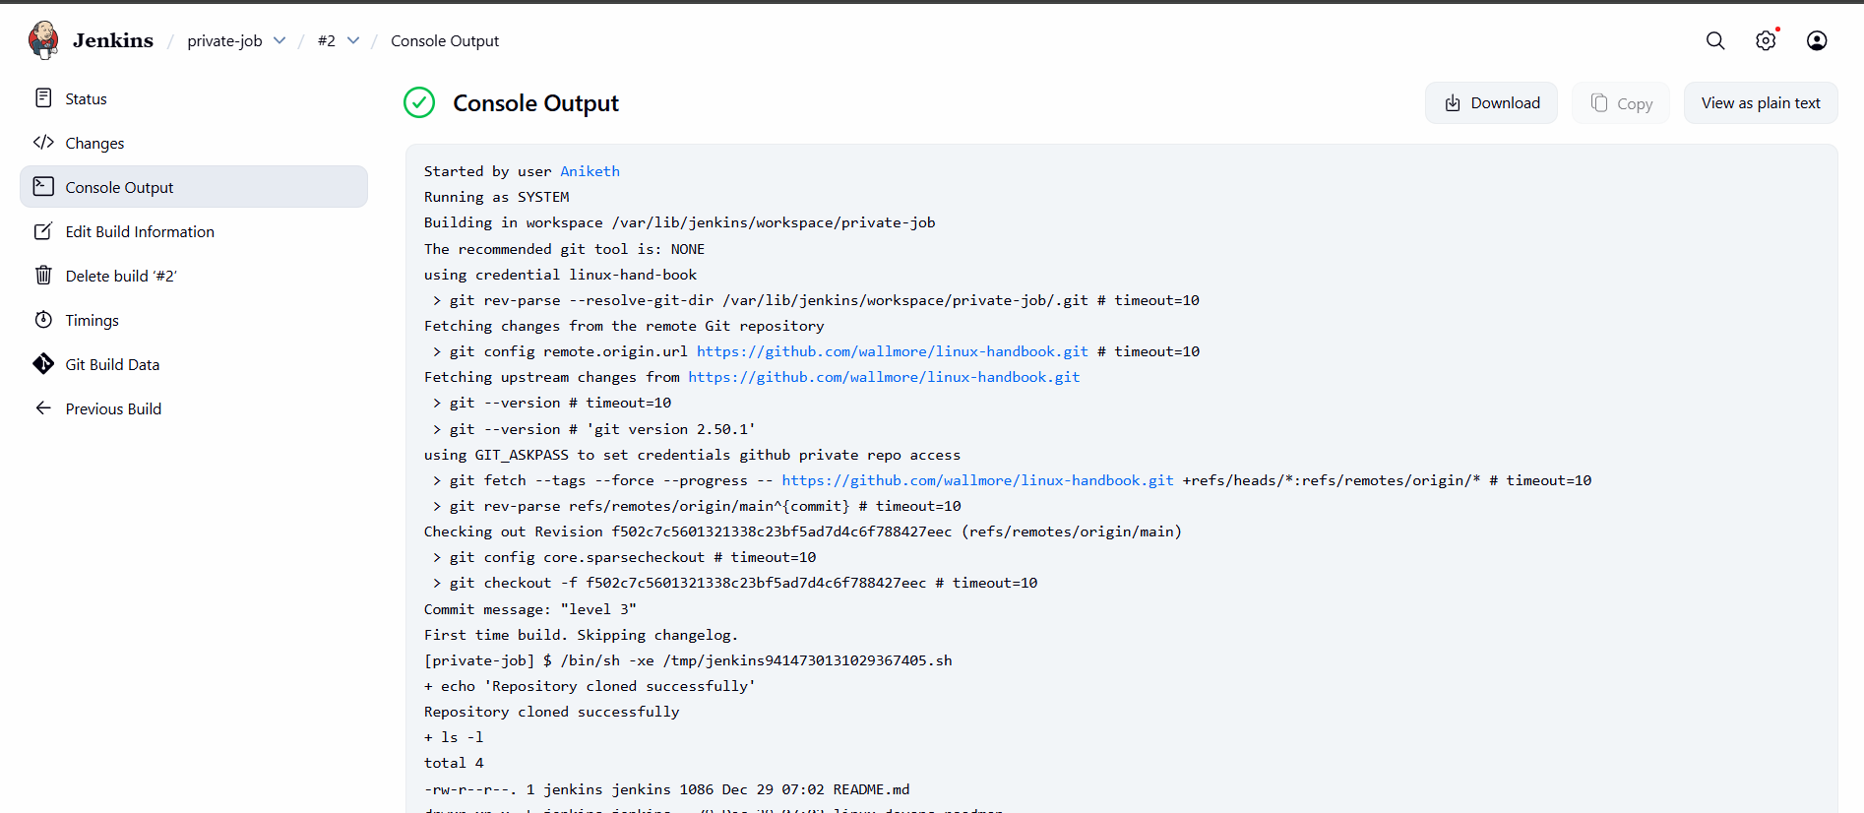

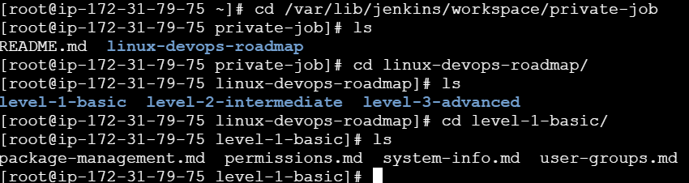

4. Conclusion

The Jenkins job was successfully created and configured to securely clone the private GitHub repository using authenticated access.
The build completed successfully, confirming proper integration between Jenkins and GitHub.

